Video Games
Final Project SQL
Nitzan Goldberg
Question 1 :
Without looking at the following tasks, what kind of business questions do you have in mind after exploring the dataset? Provide at least 2 significant examples verbally and elaborate how you would measure it.
Answer:
(1). What factors most influence a game’s global sales success?
why is this important:
publishers, developers, and investors want to know whether platform, genre, publisher reputation or ratings are the strongest drivers of sales.
this insight could help in deciding where to allocate development budgets and marketing efforts.
How to measure:
Check the correlation between Global_Sales and fields such as Genre, User_Score, Critic_Score, and Platform.
Calculate the average global sales for each genre or platform.
Compare between groups — for example, games with high scores versus games with low scores.
Examine whether there is a relationship between reviews and sales.

(2). What are the differences between regions around the world in preferences across platforms and genres?
why is this important
Each region of the world tends to have different preferences — for example, in Japan, people love dance games; in North America, action games dominate; and in Europe, sports games might be more popular.
Understanding these patterns helps companies market more intelligently, tailor campaigns, and decide in which region to launch first.
How to measure:
Compare the relative share of each region in total sales: NA_Sales, EU_Sales, JP_Sales, Other_Sales.
Calculate for each genre what percentage of its sales comes from each region.
Example SQL query:
SELECT
Genre,
Platform,
SUM(NA_Sales) / SUM(Global_Sales) AS NA_Share,
SUM(EU_Sales) / SUM(Global_Sales) AS EU_Share,
SUM(JP_Sales) / SUM(Global_Sales) AS JP_Share,
SUM(Other_Sales) / SUM(Global_Sales) AS Other_Share
FROM video_games
GROUP BY Genre, Platform;
This allows us to see, for example, that action games dominate in North America, while role-playing games are stronger in Japan.

In summary:
Both questions provide strategic insights — understanding what sells most and why and identifying where to sell and what fits best in each region.
Question 2 : Games with multiple consoles:
a. How many games have been released with 3 or more Platforms?
b. In which year were the highest number of Genres at their peak ? Please find
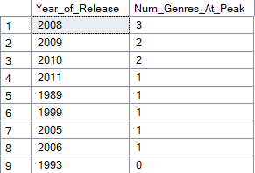
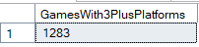
the Year & The Genres
Answer:
a. A total of 1,283 games have been released on three or more platforms.
Add a short SQL explanation line (for example: using COUNT(DISTINCT Platform) with GROUP BY Name, or using RANK() to find the peak year for each Genre).
b. The year with the highest number of genres at their peak was 2008, with a total of 3 genres reaching their maximum global sales.

Question 3: Finding the middle within the dataset:
Weighted Average: Like an ordinary arithmetic mean (the most common type
of average), except that instead of each of the data points contributing equally to the final average, some data points contribute more than others.
Average: summing the values divided by the members count.
Mode: the most common value within the dataset
Calculate the weighted average, normal Average, and the mode of critic_score perrating. Please present all numbers rounded with 1 decimal point.
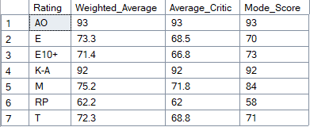
Which two ratings have the same values for all three measures? Please explain why
Answer:
The two ratings that have the same values for all three measures are AO and K-A This happens because all games within these rating categories received the same critic score value. Therefore, the weighted average, normal average, and mode are identical — since there is no variation in the data.

Weighted_Average, Average_Critic, Mode Score
Each of these calculations is performed separately and can be found in the SQL queries file, where they are marked as comments for easy reference.
Question 4 : Data Scaffolding:
Please provide the global sales by genre, Platform, and Year.
Remember: Some of the combinations in between do not exist (such as for Platform '2600' for Action genre, the years 1984-1986 lack in the data – use the query below to validate that).
SELECT DISTINCT Genre, Platform, Year_of_release
FROM video_games
ORDER BY 1, 2, 3
You are required to display the measure for all possible combinations that can be
between the fields (excluding NULLs) and bestowing zero when it's NULL for the
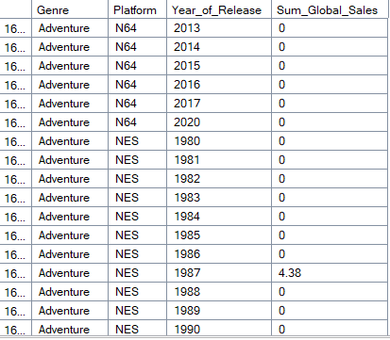
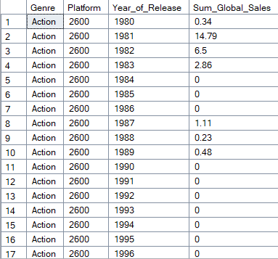
measure.
Answer:
The query builds all-possible combinations of Genre × Platform × Year_of_Release, and calculates the total global sales for each combination — even if that specific combination doesn’t exist in the original dataset.
Examples of possible combination from the Action and Adventure genres:
Question 5 : Year over Year analysis (aka: YoY)
Analyze per platform the year with the highest YoY % (Year of Year relative growth
equation > (a – b) / b), in terms of Global_Sales.
Which of the following had recorded the most significant growth rate within the
dataset, and in which year?
Note –
• In your analysis, take in account from 2nd year Global_Sales per Platform since the 1st
year does not genuinely have a YoY % value.
• Same Data Scaffolding technique should be used here.
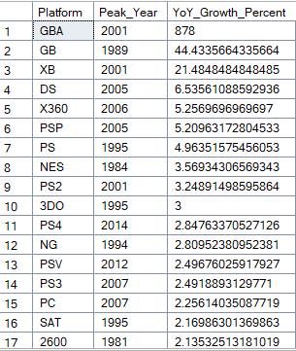
• Exclude 2020 from this data set.
Answer:
This query finds the year with the highest year-over-year (YoY) growth in global sales for each platform. It first builds a complete dataset of every possible combination of platform and release year (excluding 2020), filling in missing years with zero sales.
Then, it calculates YoY growth by comparing each year’s sales to the previous year for the same platform.
Finally, it selects the peak year — the year with the largest YoY growth percentage per platform — and sorts all platforms by that growth value.
Proof that the query is correct (Sql explanation):
SELECT Platform, Year_of_Release, SUM(Global_Sales), LAG(SUM(Global_Sales)) OVER (PARTITION BY Platform ORDER BY Year_of_Release) / LAG(SUM(Global_Sales))
OVER (PARTITION BY Platform ORDER BY Year_of_Release) AS YoY_Growth
FROM video_games
WHERE Year_of_Release < 2020
GROUP BY Platform, Year_of_Release

